Secure Coding Lab – 3

Dasari Mohan Amritesh

18BCN7038

**Code to Replicate a file 50 times in a folder:**

import shutil

import os

file = os.path.realpath('C:/Users/dmamr/Desktop/Secure lab temp/test.txt')

for x in range(1, 51):

shutil.copy(file, 'test(%s).txt' %x)

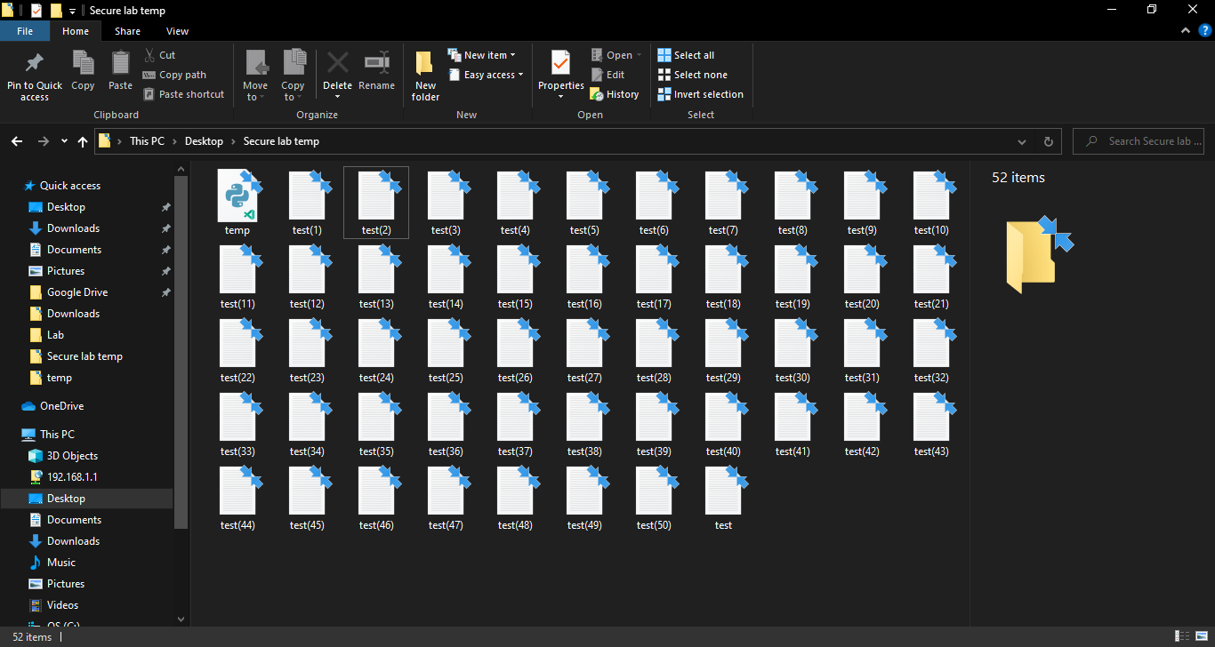

**Locating Replicated Files:**

C:\Users\dmamr>dir test(*).txt /s

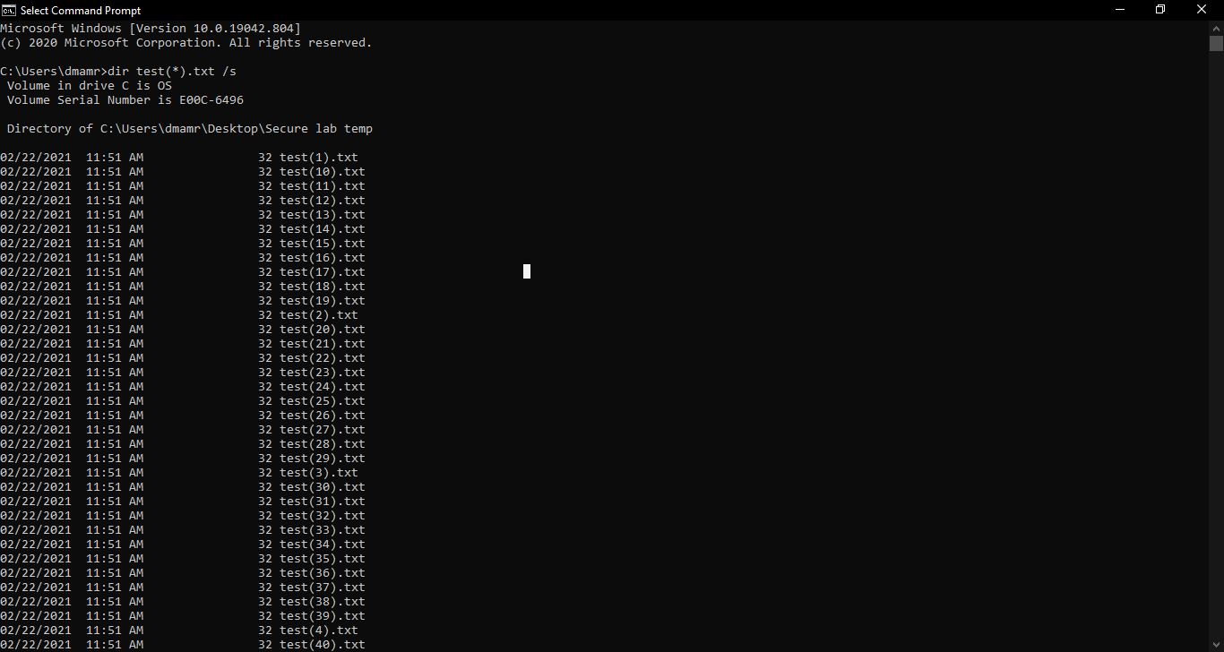

**Deleting Replicated files:**

C:\Users\dmamr\Desktop\Secure lab temp>del test(*

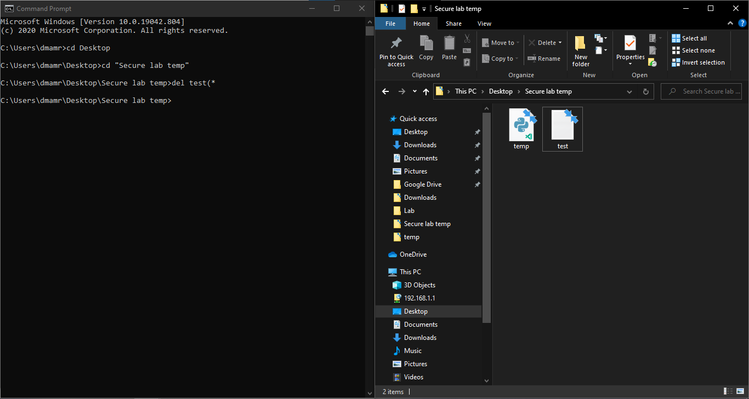

**Creating a Task:**

C:\Users\dmamr>schtasks /create /tn 18BCN7038_task1 /tr "C:\Program Files (x86)\Google\Chrome\Application\chrome.exe" /sc once /st 12:00

**Updating the Time of the Scheduled task:**

C:\Users\dmamr>schtasks /create /tn 18BCN7038_task1 /tr "C:\Program Files (x86)\Google\Chrome\Application\chrome.exe" /sc once /st 14:00

**Deleting a scheduled task:**

C:\Users\dmamr>schtasks /delete /tn 18BCN7038_task1

